**Y&G Salon Desktop View**

**Change # 1:**

Add the Contact button and Blog Button In Menu Bar **Change # 2:**

**Text will come down as per the UI (Below the face)**

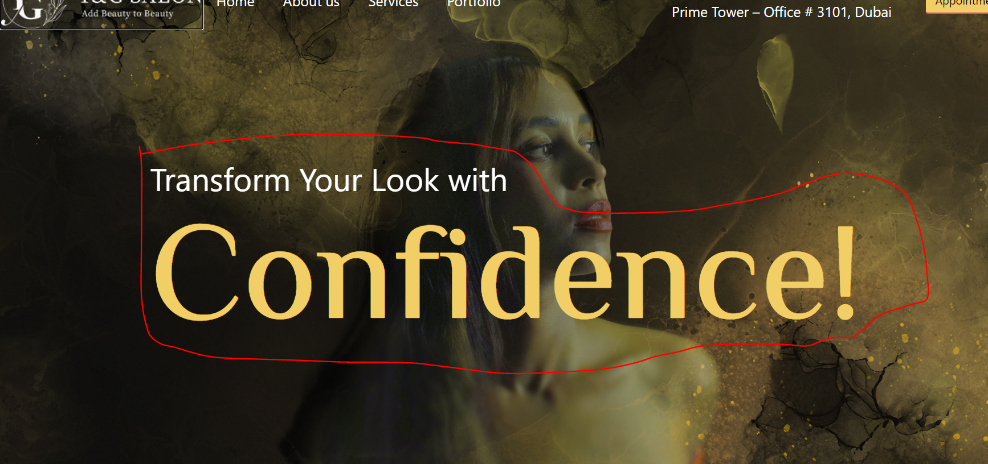

**Change #3:**Change to nail therapy

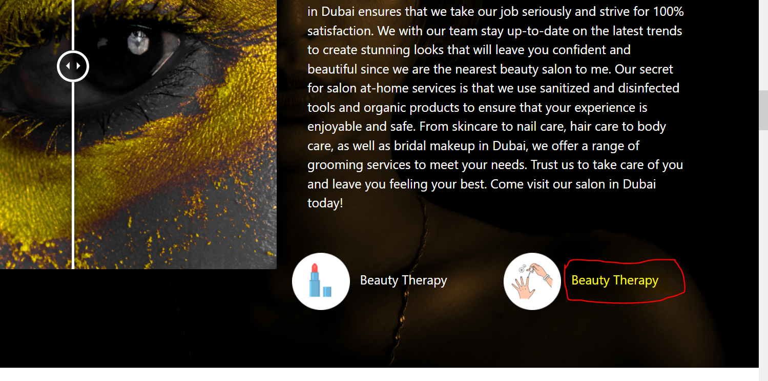

**Change #4:**

**Need to change these 4 Points.**

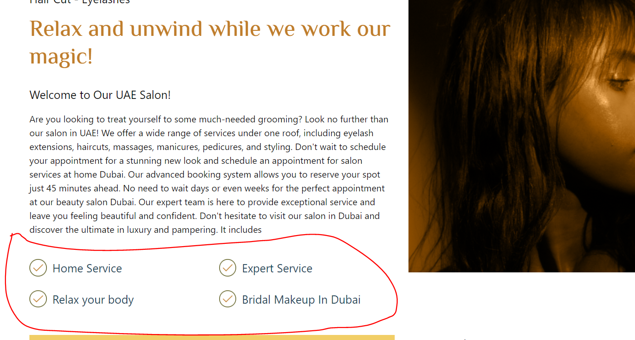

**Change #5:  
Change this image to another 1**

**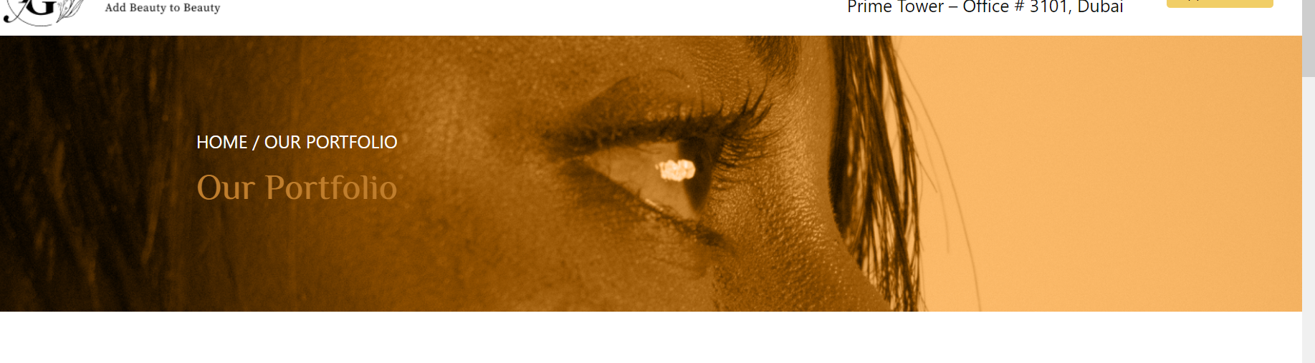  
  
To this   
  
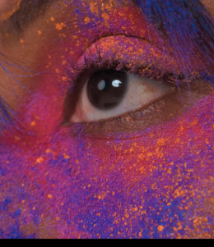**

**Change #6:**

**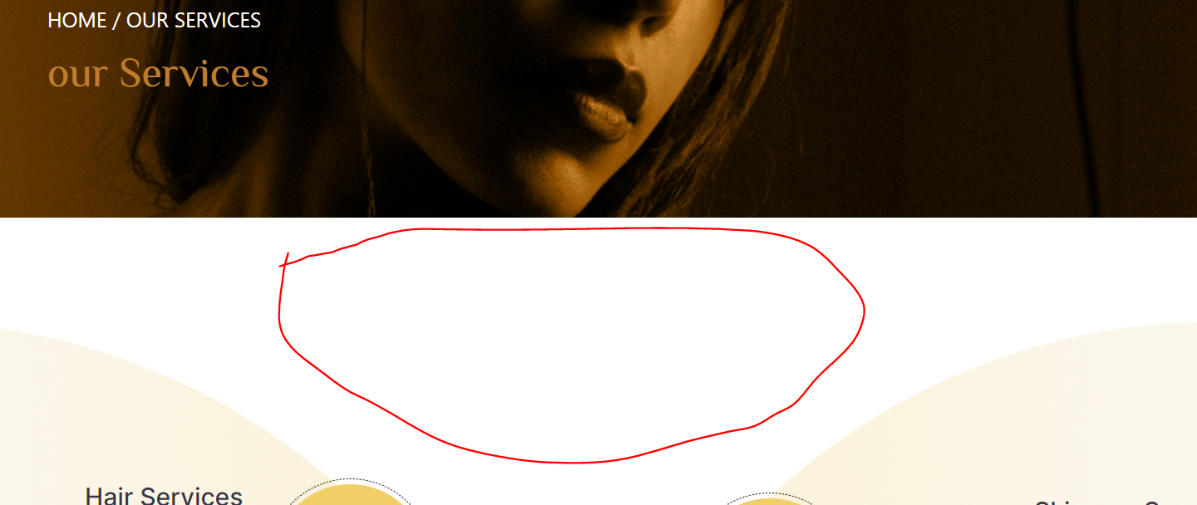  
  
Add some text like below images and the represent services**



**Change #7:  
  
Write the same number of words in the services Description so our design can looks good.**

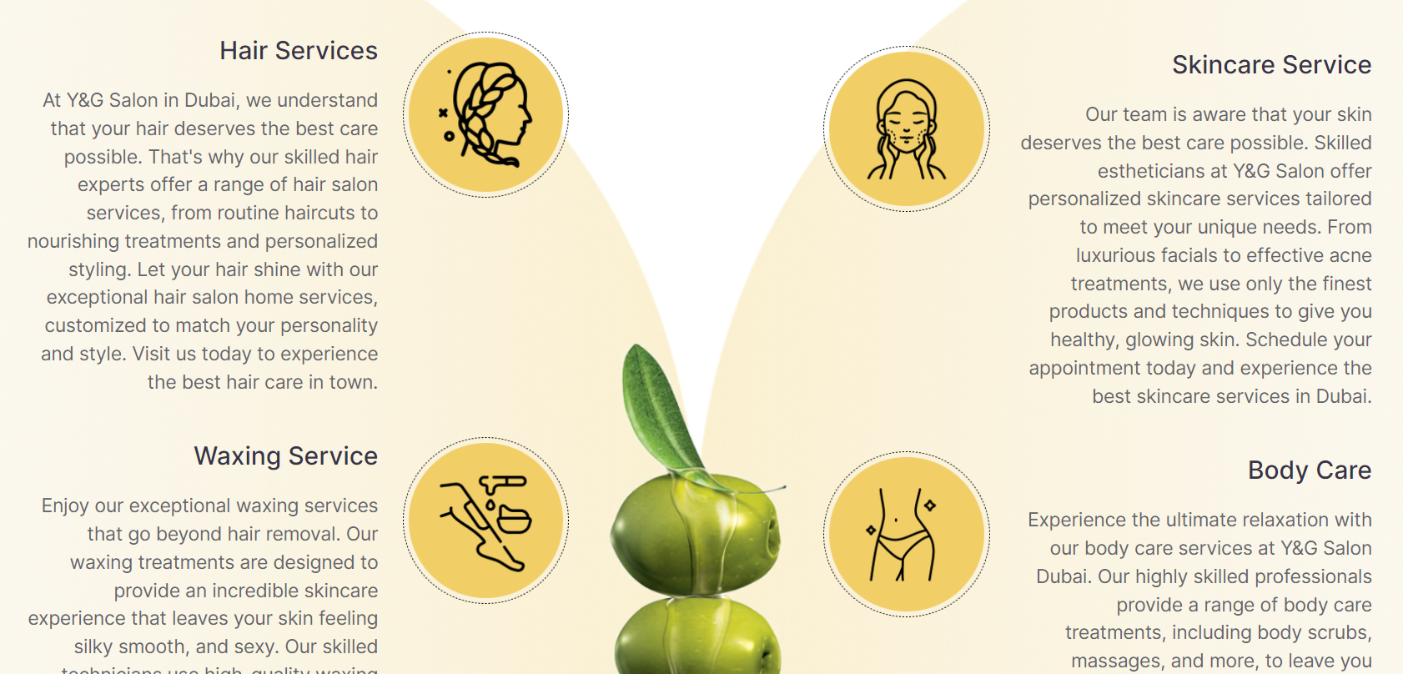

**Like Below Image   
  
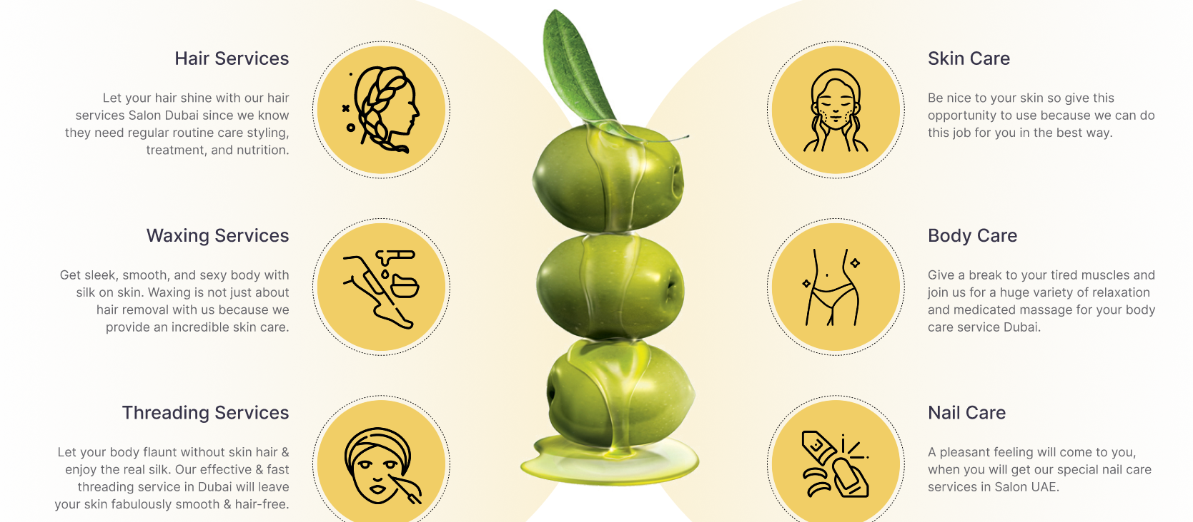**

**Change #8:**

**Change below image to this**

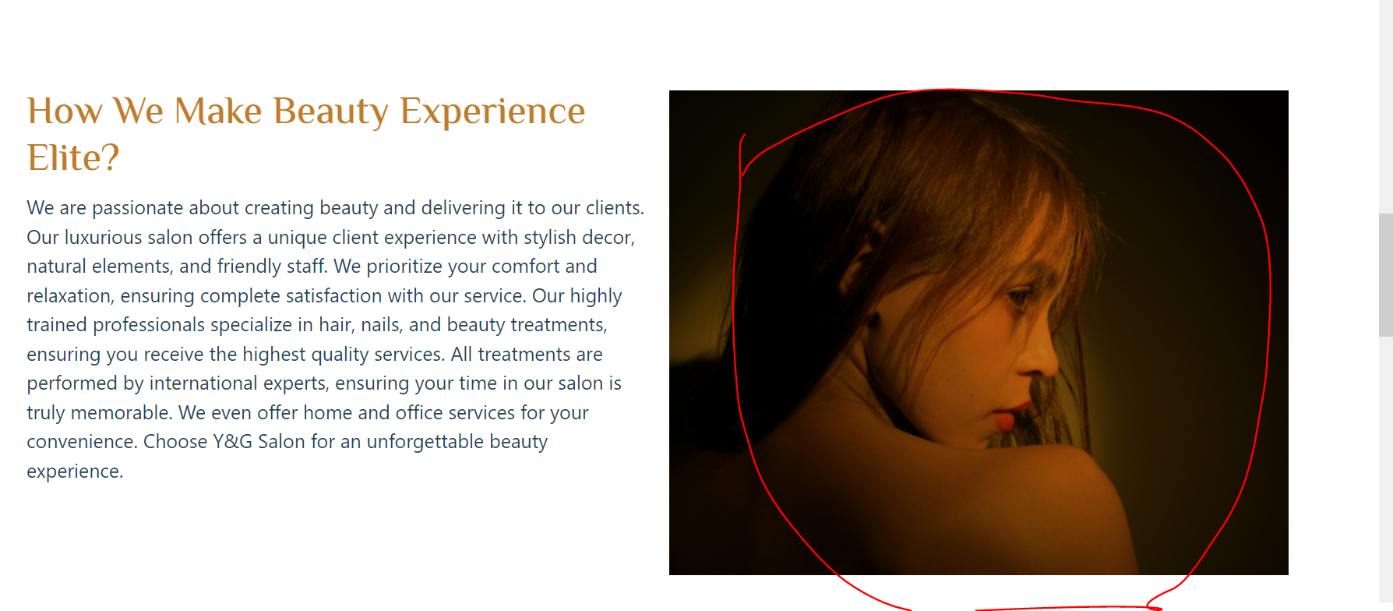

**This 1**

